Based on requirements referenced in Loop: Meetings by Indra.
The following basic requirements regarding data import will be required.
PowerBI will be used to perform calculations using either Measures or Columns.
These calculations will meet with the requirements referenced in the loop definition and also ADO282982 and ADO282983.

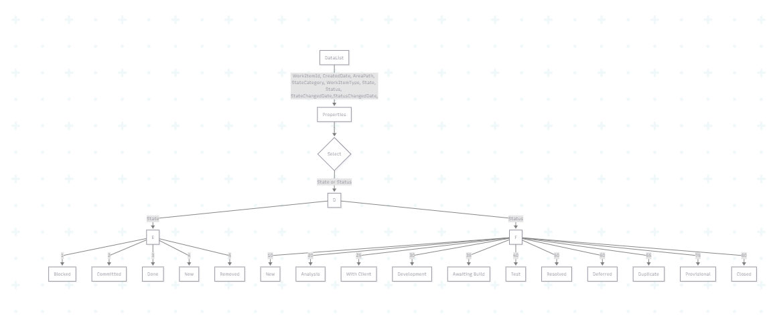
The bottom level of the State and Status are indicative of a filter box.
There will also be a requirement to identify the Work Item Type and Area Path where selections are made.
From this data, it should be possible to generate the sheets required containing Pie Charts and/or Bar Charts that have been requested.

